# **20/10/2022**

On this first day, I only focused to make backend and database for Instagram. For ERD model of the database, I use this model below from <https://app.genmymodel.com/api/repository/lc9900/Instagram>.

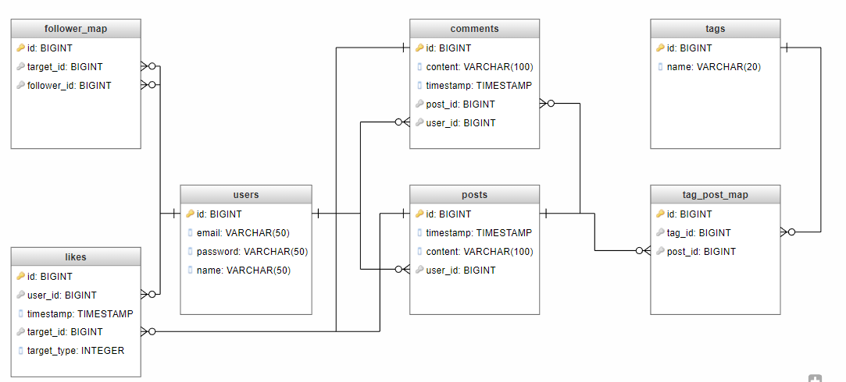

Even though I modified some of the tables. For backend, I have created folders and files structure. In the next progress, I will make all API and test them with Postman and make UI for Login page and more.